Unit Testing Guidelines

Prepared by Scott Highet
Version v0.1 DRAFT
12/03/2002

Table of Contents
1. Introduction 4
1.1. Unit Testing Approach 4
1.2. Audience 4
1.3. Contributors 4
2. Purpose and Scope of Document 5
2.1. Purpose 5
2.2. Scope 5
3. Explanation of Unit Testing 6
3.1. What is it 6
3.2. Who does it 6
3.3. Why do it 6
4. Unit Testing Techniques 7
4.1. Assume you will find errors 7
4.2. Own Checklist of Common Errors 7
4.3. Use Data most likely to cause errors 7
4.4. Use Data that make Hand-Checks easier. 7
4.5. Make sure all paths in code is covered 7
4.6. Creation of Test Stubs/Harness and Automated Unit Tests 7
4.7. Test as you go 8
4.8. Plan your tests 8
4.9. Record you Results 8
4.10. Type of things to test for 8
5. Unit Test Templates 9
5.1. Personal Development Checklist of Common Errors 9
5.2. Unit Test Plan 9
6. References 12

Version Control

Version Number | Date | Details
v0.1 | March 2002 | Initial document created

Document Update Procedure
Unit Testing Guidelines

Introduction

This document describes the approach to unit testing that is to be used to verify that each particular piece of code that has been written performs the function that it is designed to do.

Unit Testing Approach
The unit testing approach used is that each routine, method, function or class of the application being coded has its own unit test plan and if possible an automated test harness.

Audience
The audience for this document are software developers and quality managers

Contributors

Document Author | Scott Highet

Purpose and Scope of Document

Purpose
The purpose of this document is to:

- Explain unit testing
- Provide techniques on how to unit test successfully
- Provide details of templates required
- Provide a framework to work with on all projects
- Describe what needs to be included in each test

Scope
This document details on templates and techniques that are to be used by Software Developers.

It does not cover the XP Unit Testing Techniques. This will be covered in a separate document.

Explanation of Unit Testing

What is it?
Unit testing is part of the software development life cycle that ensures that each piece of code that has been written performs the function that it is designed to do.

Who does it?
The developer who wrote the code: plans, writes and executes the unit test.

Why do it?
Unit testing is performed to improve the overall quality of the software that is passed on to the testing team and then to the client. This is done by reducing the cost of defects, as you are eliminating them while the application is still being developed, rather than waiting until the system testing phase.

Unit Testing Techniques
Detailed below are some techniques that you should find useful when writing and executing Unit Tests

Assume you will find errors
A successful unit test is one that finds an error. If you write unit test plans based on your assumption that all your code is perfect you will find it hard to find any errors in your code.

Own Checklist of Common Errors
Create a checklist of your common errors (see template). This checklist is your own personal list of errors that you generate or particular functions you find hard to implement. This will help you from continually introducing these types of defects into code.

Include these tests in any unit test you create where applicable

Use Data most likely to cause errors
When writing your test plans include data that is most likely to cause an error. There is no point testing using data that will always pass.

Use Data that make Hand-Checks easier.
When executing a test that causes an error, it is a lot easier to Hand-Check the function if the data you are using is easy to manipulate. For example if you are doing some calculations on a number like 986326.34 you may more likely to make an operation error on that number rather than a number such as 90000.00.

Make sure all paths in code is covered
When writing unit test plans make sure all paths in the code are covered in at least one test. There is no need to execute the same test with all possible values if the code will always return the same result.

Creation of Test Stubs/Harness and Automated Unit Tests
With the explosion of XP (Extreme Programming) a technique that is being used is the creation of Test Stubs/Harnesses and Automated Unit Tests that allows the developer to test their code against other code written for the purpose of testing. This gives the developer the confidence of making a change in a particular part of the application, running a previously working test to check that the function still works.

However in saying that, it is sometimes required to create a Test Stub or Harness to allow entry of input data that cannot be entered anywhere else. This may mean that you can use the Stub or Harness to mimic an external or 3rd party application.

Test as you go
It is a lot easier to test as you go rather than attempting to do all your unit testing once you have completed the entire function. When estimating work add in a little bit more time for writing proper unit tests and recording results.

Plan your tests
Before coding a piece of functionality or fixing a defect, plan your unit test. This will greatly improve the quality of your change as you are already thinking about what could make this fail. See the Unit Testing Plan Template for the format to follow.

Record your Results
Use the Unit Test Plan template to record your testing results. These can then be stored in a sub project of the Visual Source Safe project.

Type of things to test for
When writing the unit test consider the following when looking for things to test:

    - Functional
Does the piece of code functionally perform the task it is designed to do?
    - Boundaries
What are the minimum, maximum values for the function, will the function accept strange characters, reserved SQL characters, alpha and numeric values? What happens if they are not within these boundaries?
    - Termination
What happens in the normal termination of the function? What about an abnormal termination of the function? Will the application continue or will an error occur. Is the error trapped?
    - Outputs
What are the expected outputs of the function? Where do they go, what else uses them, what happens if the output is nothing? What happens if the output cannot be passed to the next function? i.e. The database was unavailable when attempting to write to it
    - Algorithms and Computations
Do all the algorithms and computations work, what happens if the wrong values are passed to them, are the variables stored as correct types i.e. will the result exceed 32267 (integer)

    - Inputs
What are the expected inputs to the function? Where do they come from? What happens if they do not get passed in? What happens if they are the wrong type? i.e. an alpha instead of a numeric. Do they rely on any third party application?
    - Interaction
What other modules/functions does this interact with? Will those be effected by the change?
    - Transactions
What type of transactions will occur? What will happen if a single transaction fails, is interrupted or succeeds? Are the transactions event driven, system initiated, user driven, or time driven?

Unit Test Templates

Personal Development Checklist of Common Errors
A personal checklist of common errors is used by a developer as a reminder of possible errors generated due to personal development traits, lack of complete understanding in certain areas of the application or development language. This checklist is to be used in conjunction with the Development Checklist.

This is an example of a Personal Checklist of Common Errors, the template can be found at put template here

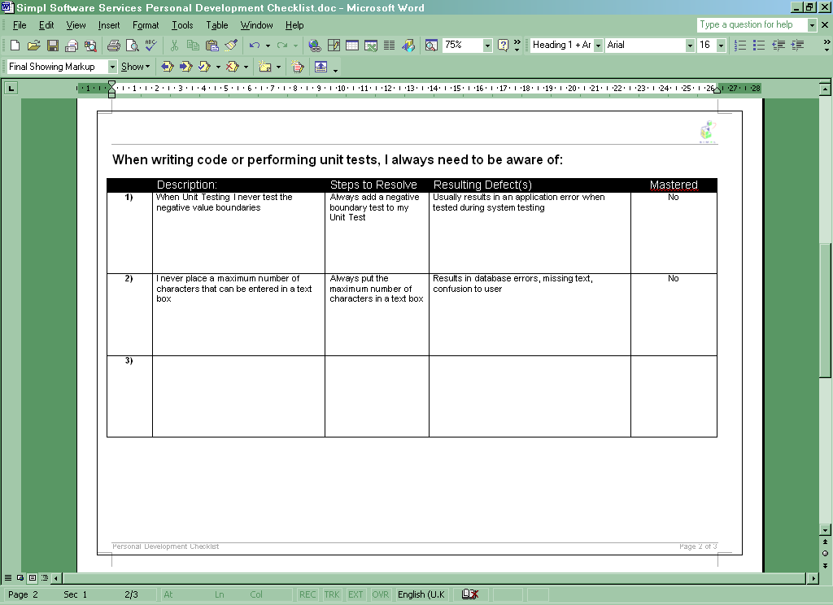
Description of Problem
Steps to prevent it
Resulting Defects if not prevented
If Problem has been mastered

Unit Test Plan
The Unit Test Plan is the document that describes the Unit Test and records the results.

Each Test must have actions, inputs, expected results/outputs, actual results and a Pass/Fail mark. There is a reference to the Client, Project, Developer, Module and Function.

It must also include a reference to the function in the design document, the defect number or change request number.

The actions can be determined by using the Unit Test Techniques detailed earlier in this document.

The Unit Test Plan must be stored in Visual Source Safe under a Unit Test sub project of the project. This ensures the test plan is kept with the source, allow others working on the source to use it and for it to be reused for future versions.

The Unit Test Plan can be as brief or verbose as the Developer or the Project Manager thinks is necessary for the project, as long as the Test Plan describes and tests to the appropriate level.

This is an example of a Unit Test Plan. The template can be found at put template here

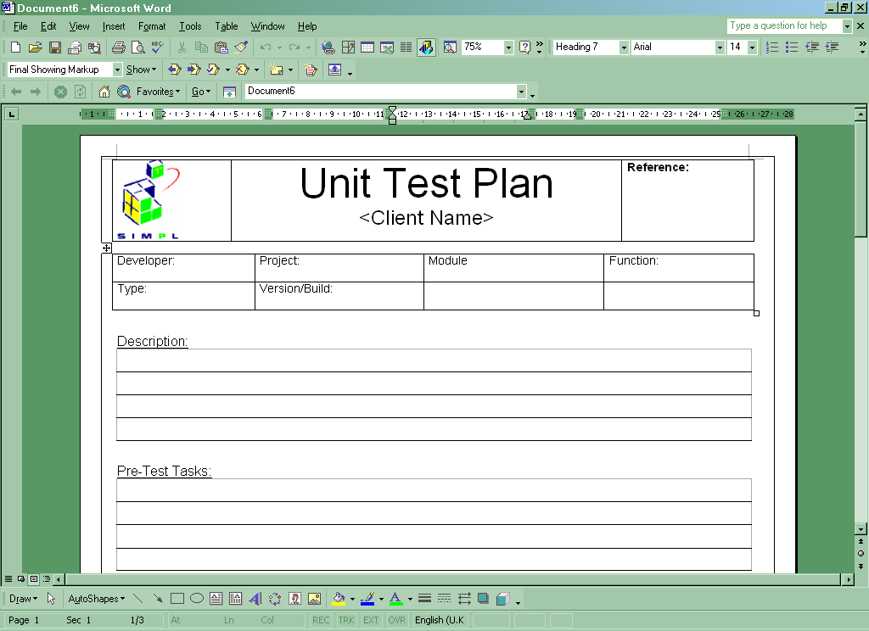
Client Name
Reference to Design, Change Request or Defect
Details of Developer / Project / Module and Function
Description of Test
Details of any pre-execution tasks

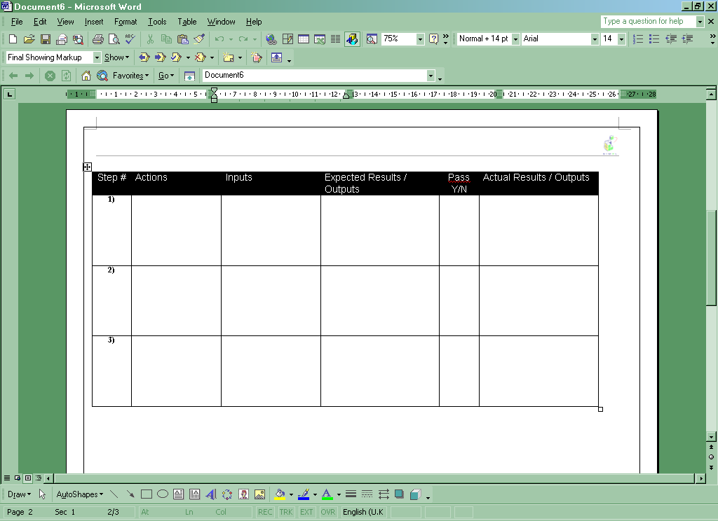
Actions to be performed
Inputs Required (if any)
Expected Results and Outputs
If the Test Pass or Failed
Actual Results and Outputs

References

References used in the creation of this document and for further reading.

- Code Complete, Chapter 25 ‘Unit Testing’ by Steve McConnell
- Effective Methods for Software Testing by William Perry
- Stickyminds.com
- QA Forum Team Services Site

